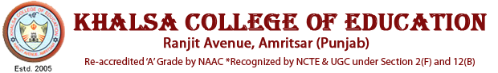

**ALUMNI ASSOCIATION**

**PARENT TEACHER ASSOCIATION**

**SUPPORT STAFF**

**DATA ENTRY OPERATOR**

**OFFICE SUPERINTENDENT**

**CULTURAL COMMITTEE**

**EXAMINATION COMMITTEE**

**CURRICULUM DEV. CELL**

**CURRICULAR**

**VICE PRINCIPAL**

**COORDINATORS**

**FACULTY**

**SC/ST/OBC & MINORITY COMMITTE**

**INTERNAL COMPLAINT CELL**

**GRIEVANCES AND REDRESSAL CELL**

**ANTI RAGGING CELL**

**PLACEMENT CELL**

**NSS**

**SPORTS COMMITTEE**

**LIBRARY COMMITTEE**

**TIME TABLE COMMITTEE**

**CO-CURRICULAR**